**Introduction**

Asset classes are groupings of investments that share similar characteristics and are bound by the same laws and regulations. Among common asset classes are equities, fixed income, commodities, and real estate, and I am going to argue that music royalties fit perfectly in this list of asset classes.

So, what is these royalties meaning exactly then? Music Royalties can be defined as the payments made to right holders, which includes songwriters, composers, and music publishers in exchange for the use of their musical compositions/songs.

**Section 1: The Appeal of Music Royalties**

Historically, the music industry's financial performance has shown minimal correlation with broader economic trends. Despite economic downturns, music spending and royalties have remained resilient, a trend especially noticeable during the COVID-19 pandemic. Unlike many other sectors, both recorded music and music publishing revenues have not exhibited a clear connection to overall consumer spending patterns.

Goldman Sachs' analysis underscores this disparity by contrasting the music industry's 15-year decline due to piracy with its subsequent resurgence fueled by streaming services. Their "Music in the Air" report reveals that since 2016, recorded music spending has surpassed the growth of personal consumer expenditures by a significant margin of 2.4 times.

Furthermore, music publishing income has demonstrated remarkable resilience across economic cycles. Data from CISAC collections indicate steady growth even during the tumult of the Great Recession.

Examining public equity markets, we find further evidence of the unique relationship between music intellectual property (IP) assets and the broader market. Mills Music Trust (MMTRS) exhibits a beta of -0.65, suggesting an inverse correlation with market movements. Conversely, Hipgnosis Songs Fund (SONG-GB) boasts a beta of 0.21, indicating substantially lower volatility compared to the broader market.

The appeal of song royalties as an investment asset stems from their stability, recurring income streams, attractive relative yields, and historically low correlation with broader economic fluctuations. These factors collectively position music royalties as an enticing asset class for investors seeking stability and resilience in their portfolios. (Stone, N/A)

**Low Correlation of Record Music Spend with Personal Consumer Expenditures (PCE): 1994-2019**

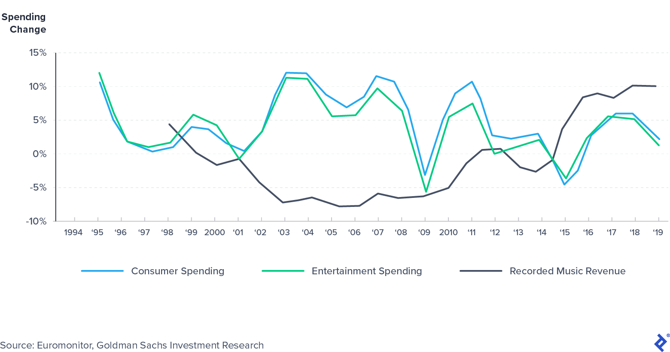

The trajectory of song popularity often follows a predictable pattern, with peaks occurring in the initial years post-release, followed by a gradual decline over the subsequent two to three years, before stabilizing after approximately five to seven years. Established catalogs, brimming with well-established content, benefit from this predictability and maintain stable consumption patterns. The wealth of historical data associated with seasoned content facilitates detailed analysis, including meticulous decay curve modelling and rigorous statistical examination.

Conversely, newer songs and current chart-toppers may lack extensive historical data. Yet, they present promising opportunities for significant growth potential, albeit with inherent uncertainties. (Wei, 2023)Top of Form

In the current financial landscape, where investors seek returns without exposing themselves to excessive risk, music royalties emerge as an attractive investment avenue. Comparing yields across various assets as of September 2020 provides context:

* The US 10-year treasury yield stood at a mere 0.7%.
* The S&P 500 dividend yield offered 1.8%.
* Vanguard High-yield Corporate Bond (VWEHX) yielded 3.9%.

In contrast, music royalties present compelling figures during the same period:

* Royalty Exchange reported an average annualized return on music investment exceeding 12% for music catalogs sold on its platform, which shows how well does royalty in finance do.
* Hipgnosis Songs Fund (SONG) boasted a dividend yield of 4.3%.
* Mills Music Trust (MMTRS) delivered an impressive dividend yield of 9.6%.

However, it's crucial to acknowledge the inherent volatility in music royalty income. As previously discussed, royalty cash flows for a song typically diminish over time. Therefore, while the past 12 months may have yielded substantial income, future returns are not guaranteed to match or exceed this figure. Investors should approach music royalties with a nuanced understanding of their fluctuating nature and potential income variability. (Stone, N/A)

**Section 2: Market Dynamics**

*“I think everyone realized that publishing catalogs were assets you could finance, like a building. And the forecasts the investment banks are making for the number of streaming subscribers in the next 10 years are extraordinary. So investment bankers, hedge funds, private equity – they all look at this as an asset class.”* — [Martin Bandier](https://www.billboard.com/articles/business/8504735/martin-bandier-leaving-sony-atv-interview), former CEO and chairman of Sony/ATV Music Publishing

According to a report from Goldman Sachs, the global music market, which encompasses music publishing, recording, and live performances, is estimated to be valued at around $60 billion. This figure reflects the significant role music plays in our world today, facilitated by the widespread accessibility provided by streaming services like Spotify, Amazon, and Apple Music. These platforms have witnessed a remarkable surge in popularity, as highlighted by Goldman Sachs, with Spotify alone experiencing nearly a fivefold increase in streaming hours between 2015 and 2021. Moreover, the influx of tens of thousands of new songs onto platforms daily underscores the dynamic nature of the industry.

Beyond traditional avenues, music has seamlessly infiltrated various other platforms, including gaming, home fitness, and social media, further broadening its reach and influence in today's digital landscape, which is no surprise as effective music distribution is essential for reaching a wider audience and maximizing sales in today's digital age. (Wei, 2023)

**Section 3: Investment in Music Royalties**

Investing in music intellectual property (IP) presents several avenues for potential investors:

1. **Record Labels and Publishers:** While direct investment in traditional record music labels and publishers can be challenging due to their often being part of larger conglomerates or privately owned entities, some are making moves towards public offerings. For instance, Warner Music Group conducted its IPO in June 2020, and Vivendi has announced plans for an IPO of its subsidiary, Universal Music Group, by 2023 or earlier.
2. **Music Royalty Funds:** These funds, which mainly operate in the private market, provide exposure to music royalties. While most are private, a few are publicly traded. Examples include Hipgnosis Songs Fund and Mills Music Trust, which own interests in music royalties and distribute cash flow to shareholders. However, private royalty funds typically require substantial minimum investments, often targeting institutional and ultra-high net worth investors.
3. **Direct Purchases of Music IP:** Royalties websites like Murilex facilitate direct ownership of music IP assets in the private market. These platforms offer opportunities for smaller investors, with deal sizes ranging from $5k to less than $1 million. Investors can also opt for passive interests in song catalogues, allowing them to collect ongoing distributions akin to "mailbox money." However, assessing the value of a music catalogue requires diligent effort from investors, as opposed to relying on the expertise of major record labels, publishers, or music royalty fund managers.

Each avenue has its own set of considerations and risk factors, so investors should conduct thorough research regarding the royalty technology mentioned above and consider their investment goals before diving in.

**Section 4: Diversification Benefits**

Music royalties represent an excellent asset for diversification within investment portfolios for several reasons. First, they exhibit a low correlation with traditional financial markets, offering stability even during market volatility. This stability is further reinforced by the consistent cash yield generated from music royalties, supported by ongoing demand across various platforms. Additionally, the resilience of music royalties against market fluctuations is evident, as the consumption of music remains relatively unaffected by economic cycles. Moreover, investing in music royalties provides access to diversified revenue streams from multiple channels, including streaming, sales, performances, and licensing. Recent market activity, marked by high-profile catalog transactions, underscores the growing interest and perceived value in music royalties, highlighting their liquidity and potential for growth. Overall, incorporating music royalties into investment portfolios offers investors an opportunity to diversify their holdings, benefit from stable cash flows, and tap into a resilient and expanding asset class.

**Section 5: Monetization and Copyrights**

Like other forms of asset-based investing, music royalty investments are underpinned by a financial asset: music intellectual property (IP) rights that generate consistent royalty income. Music monetization is anchored on the foundation of two types of copyright: publishing rights and master rights. Publishing rights pertain to a song’s composition, which may include both the melody and accompanying lyrics. Master rights pertain to a specific sound recording or reproduction of a song. As an example, Leonard Cohen composed the iconic melody and lyrics of “Hallelujah,” which accounts for the publishing rights, but over the years, there have been many artist recordings (most famously by Jeff Buckley) with associated master rights. (Wei, 2023)

The two types of copyrights generate revenue through the following royalty streams:

1. Mechanical Royalties, which are earned when a song is reproduced. An example of that would be when a physical copy (a CD) or it is downloaded digitally. You must be familiar with Spotify and Apple Music, which pay mechanical royalties for the use of songs on their platforms.
2. Performance Royalties, as it can be deduced from the name, are royalties earned when the song is performed publicly, such as in radio broadcasts, when the music is played in public places, or live performances. It can even go as far as earning performance royalties for music played over the phone for callers who are put on hold.
3. Print Music Royalties, which are earned when sheet music or music notation is sold or used.
4. Synchronization (Sync) Royalties. These are earned when a song is used along visual media like TV shows, commercials or video games.
5. Foreign Royalties, which are among the harder ones to collect, because they are earned when music is used/performed outside the creator’s home country and international regulations and agreements might get in the way of collecting the royalties.
6. Lyricist Royalties, which are royalty payments made to the person or people who wrote the lyrics of a song.

Recent high-profile transactions in the music royalties market highlight its burgeoning appeal as an investment avenue. These deals, including KKR's bond issuance and Hipgnosis and Round Hill's privatization moves, underscore the market's robust valuation and liquidity. Investors are drawn to music royalties for their stability, with income streams stemming from streaming, sales, and licensing. Independent artists benefit from monetizing their catalogs while retaining control over their legacies. These transactions set industry precedents, shaping future deals and investment strategies. Music royalties offer investors diversification and resilience in uncertain markets. As the market matures, its enduring value and cultural significance make it an increasingly attractive investment opportunity.

**Conclusion**

In conclusion, music royalties present a stable and lucrative investment opportunity for both investors and artists, including independent music artists. Their resilience against economic downturns, diversified revenue streams, and low correlation with traditional financial markets make them an appealing asset class. Recent high-profile transactions underscore their growing recognition as valuable investments, offering diversification and stable returns.

Looking ahead, the future of music royalties looks promising, with continued growth in the global music market and the rise of streaming services. This evolution presents opportunities for investors to diversify portfolios and capitalize on the expanding market. For artists, music royalties offer a means of financial security and legacy management by monetizing their creative works.

Overall, music royalties represent the intersection of art and commerce, offering financial opportunity and artistic expression. As stakeholders embrace innovation and collaboration, they can harness the transformative power of music royalties to shape a prosperous future for the music industry.